Q). Write a Python program to accept the user's first and last name and then getting them printed in the the reverse order with a space between first name and last name.?

x= input('Enter your first name ')

y=input('Enter your Last Name ')

z=x+' '+y

print(z[::-1])

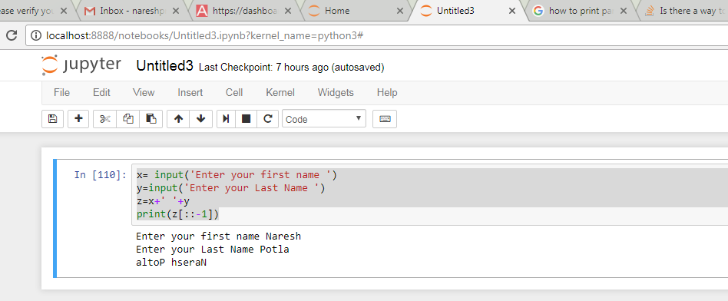

Q). Write a Python program to find the volume of a sphere with diameter 12 cm ?

r=int(input('enter diameter of sphere '))

v=(4/3)\*3.14\*(r/2)\*\*3

print(v)

